
Environmental Review
Tribunal

Case Nos.: 11-058/11-059/11-060/11-061/
11-062/11-063/11-064/11-065/11-066/11-074

Dea v. Director,
Ministry of the Environment

In the matter of an appeal by AbiBow Canada Inc., Abitibibowater Inc., Abitibi-Consolidated Company of Canada, Pierre Rougeau, David J. Paterson, Allen Dea, Jacques P. Vachon, William G. Harvey and Alain Grandmont filed May 27, 2011 and OfficeMax Incorporated filed May 30, 2011 for a Hearing before the Environmental Review Tribunal pursuant to section 140 of the Environmental Protection Act, R.S.O. 1990, c. E.19, as amended, with respect to Order No. 6248-8GRHU2 issued by the Director, Ministry of the Environment, on May 13, 2011 under sections 18, 44, 132 and 196 of the Environmental Protection Act regarding the property known as the Mud Lake Waste Disposal Site located in the City of Kenora, Ontario; and

Case Nos.: 11-144/11-146/11-147/11-148/11-149/
11-150/11-151/11-152/11-153/11-154

Office Max Incorporated v. Director,
Ministry of the Environment

In the matter of appeals by Office Max Incorporated filed August 30, 2011 and by AbiBow Canada Inc., Abitibibowater Inc., Abitibi-Consolidated Company of Canada, Pierre Rougeau, David J. Paterson, Allen Dea, Jacques P. Vachon, William G. Harvey and Alain Grandmont filed August 31, 2011 for a Hearing before the Environmental Review Tribunal pursuant to section 140 of the Environmental Protection Act, R.S.O. 1990, c. E.19, as amended; with respect to an Order issued by the Director, Ministry of the Environment, on August 16, 2011 under section 18, 44, 132, 196 and 197 of the Environmental Protection Act, regarding the property known as Margach Waste Disposal Site located in the City of Kenora, Ontario; and

Case Nos.: 11-155/11-156/11-157/11-158/11-159/
11-160/11-161/11-162/11-163/11-175

Grandmont v. Director,
Ministry of the Environment

In the matter of appeals by AbiBow Canada Inc., Abitibibowater Inc., Abitibi-Consolidated Inc., Bowater Canadian Forest Productions Inc., Pierre Rougeau, David J. Paterson, Jacques P. Vachon, William G. Harvey and Alain Grandmont filed September 9, 2011 and by Weyerhaeuser Company Limited filed September 16, 2011 for a Hearing before the Environmental Review Tribunal pursuant to section 140 of the Environmental Protection Act, R.S.O. 1990, c. E.19, as amended; with respect to an Order issued by the Director, Ministry of the Environment, on August 25, 2011 under section 18, 44, 132, 196 and 197 of the Environmental Protection Act, regarding the property known as Bowater Mercury Waste Disposal Site located in the Town of Dryden, Ontario; and
In the matter of telephone conference calls held on December 6, 2011, January 27, March 8, April 16, May 23, July 26, September 18, November 19, 2012, January 29, March 28, May 23, July 23, September 24 and December 3, 2013.
Before: Alan D. Levy, Member
Appearances:
Dennis Mahony and - Counsel for the Appellants, AbitibiBowater Inc, AbiBow
Tyson Dyck Canada Inc., Abitibi-Consolidated Company of Canada,
Abitibi-Consolidated Inc., Bowater Canadian Forest
Productions Inc., Pierre Rougeau, David J. Paterson,
Allen Dea, Jacques P. Vachon, William G. Harvey and
Alain Grandmont
Elizabeth Putnam, - Counsel for the Appellant, Office Max Incorporated
Jennifer Fairfax and
Patrick Welsh
Gabrielle Kramer - Counsel for the Appellant, Weyerhaeuser Company
Limited
Mario Faieta and - Counsel for the Director, Ministry of Environment
Justin Jacob

Dated this 10th day of January, 2014.

REASONS FOR DECISION
Background
- Three separate Director’s Orders have been issued by Trina Rawn, a Director in the Ministry of Environment (“MOE”), each one dealing with a different facility. Most of the orderees named in these Director’s Orders have appealed to the Environmental Review Tribunal (“Tribunal”) pursuant to s. 140.(1) of the Environmental Protection Act (“EPA”). As discussed below, three orders were issued on consent in 2011 by the Tribunal on an interim basis pending the outcome of the appeals. Progress with proceedings since then is dealt with in this order.
- Many, but not all, of the appellants are the subject of all of these Director’s Orders, and are represented by the same counsel. They requested that the initial phase of the appeals be dealt with in a series of joint telephone conference calls (“TCCs”) prior to the Tribunal convening one or more preliminary hearings. In addition to counsel, some of the teleconferences discussed below have also been attended by the Director and other MOE staff members.
- The appellants are variously alleged by the Director’s Orders to have some degree of current or historical responsibility, in one capacity or another (as former owners or operators, corporate officers or directors, etc.), to address environmental issues which are considered by the MOE to be outstanding with respect to one or more of the three sites. For a variety of similar and different reasons the appellants deny that they are responsible for dealing with current environmental issues at these sites, and seek to have the Tribunal dismiss the Orders.
- The first Director’s Order (“DO-1”), No. 6248-8GRHU2, is dated May 13, 2011, and has been referred to by counsel as the Mud Lake Order. The Mud Lake Waste Disposal Site (“WDS”) is located in the City of Kenora and constitutes a waste pile consisting primarily of wood bark from a now-closed pulp and paper production facility. This WDS was created in 1973 and continued in use until the mid-1980s when it reached its capacity of one million cubic metres of waste.
- Among other things, the concerns of the Director as reflected in DO-1 relate to abandonment of the site, a failure of the leachate pumping system, an overflow of surface water drainage collected in Mud Lake, discharge of contaminants into the environment, and the need for provision of additional financial assurance.
- The parties involved with DO-1 reached an agreement pending appeal with respect to a stay of some that Order’s provisions and amendments to others, as well as an adjournment to permit ongoing settlement discussions. These matters were addressed in my order of June 13, 2011, along with an extension of time for the appellants to provide information required by the Tribunal to convene a preliminary hearing.
- The second Director’s Order (“DO-2”), No. 8301-8HFPUQ, is dated August 16, 2011, and has been referred to by counsel as the Margach Order. The Margach WDS, also located in the City of Kenora, is an 11-acre landfill which received non-hazardous waste material from the same facility as the Mud Lake WDS. This waste included wood room bark, primary clarifier sludge, biosolids from a secondary treatment facility, sludge from a recycle facility, general wood waste, ground scrapings, boiler ash and clinkers. This WDS was in use from 1986 (after the Mud Lake WDS reached capacity) until 2009, and contains a reported volume of 1,204,700 cubic metres of waste.
- According to DO-2, the Margach WDS was established in 1986 by Boise Cascade Canada Ltd. as a landfill to service its pulp and paper mill in Kenora. The mill ceased operations in 2005, and was demolished between 2007 and 2009. Demolition debris from the mill was also deposited at this site, concluding in October 2009.
- Among other things, the concerns of the Director as reflected in DO-2 relate to closure of the landfill, the lack of impervious final cover, off-site migration of surface and ground water contaminated by leachate, and the need for provision of additional financial assurance.
- The parties involved with DO-2 reached an agreement pending appeal with respect to a stay of some of that Order’s provisions and amendments to others, as well as an adjournment to permit ongoing settlement discussions. These matters were addressed in my order of December 2, 2011, along with a further extension of time for providing information required from the appellants to convene a preliminary hearing.
- The third Director’s Order (“DO-3”), No. 4345-8HFPHW, dated August 25, 2011, deals with the Bowater Mercury WDS and has been referred to by counsel as the Dryden Order. This WDS is located in the Town of Dryden and was created in 1971 for the disposal of mercury contaminated waste from the demolition of a local mercury chloroalkali plant. The plant’s owner, Reed Ltd., had produced chemicals (sodium hydroxide and chlorine) used for bleaching paper. The production process caused the plant’s building and associated equipment to become contaminated with trace amounts of mercury. During the period from 1971 until 1981, eight concrete cells containing mercury-contaminated rubble, stabilized sludge and equipment, were buried at this WDS.
- The parties involved with DO-3 reached an agreement pending appeal with respect to a stay of some of that Order’s provisions and amendments to others, as well as an adjournment to permit ongoing settlement discussions. These matters were addressed in my order of November 18, 2011, along with an extension of time for providing information required from the appellants to convene a preliminary hearing.
- The above-noted orders of the Tribunal addressed matters which arose in the TCCs conducted on June 3, July 15, August 17, September 26, September 28, October 31 and November 4, 2011. TCCs since then have been held on December 6, 2011, January 27, March 8, April 16, May 23, July 26, September 18, November 19, 2012, January 29, March 28, May 23, July 23, September 24 and December 3, 2013. All of these TCCs were scheduled with the agreement of counsel. Each successive adjournment has also included the extension of the deadline for appellants to provide information requested by the Tribunal in order to convene a preliminary hearing.
- As indicated in my previous orders a significant delay in these proceedings has been due to an appeal to the Supreme Court of Canada (“SCC”) from a decision of the Quebec Court of Appeal. It involved the issue of whether certain types of provincial environmental protection orders constitute ‘claims’ under the federal Companies’ Creditors Arrangement Act, R.S.C. 1985, c. C-36. Among the respondents in that appeal are AbitibiBowater Inc., Abitibi-Consolidated Inc. and Bowater Canadian Holdings Inc.
- A significant issue in the appeals from these Director’s Orders is the effect of the insolvency of some of the corporate appellants on the MOE’s authority to include them as orderees. Although the SCC appeal involved unrelated sites and some other parties, counsel anticipated that the outcome would be important in determining the insolvency issue in these appeals before the Tribunal. Oral argument before the SCC was heard in November 2011 and the Court’s decision was delivered on December 7, 2012. The reasons for judgment of the SCC are reported in Newfoundland and Labrador v. AbitibiBowater Inc., 2012 SCC 67.
- Since then, counsel have been moving forward with negotiations in a continuing effort to resolve these appeals. During the TCC on July 23, 2013, counsel for the Director and the group of appellants represented by Dennis Mahony and Tyson Dyck (AbitibiBowater Inc, AbiBow Canada Inc., Abitibi-Consolidated Company of Canada, Abitibi-Consolidated Inv., Bowater Canadian Forest Products Inc., Pierre Rougeau, David J. Paterson, Allen Dea, Jacques P. Vachon, William G. Harvey and Alain Grandmont) requested some changes to the Tribunal’s orders involving DO-1 (the Mud Lake Order) and DO-2 (the Margach Order). Mr. Mahony also advised that the appellant AbitibiBowater Inc. had changed its name to Resolute Forest Products Inc. Two new draft Interim Orders with appended Schedules were circulated on that date.
- At the TCC on September 24, 2013, Mr. Dyck advised that further amendments are now required and that new draft Interim Orders would be prepared and circulated. Mario Faieta, counsel for the Director, indicated that an affidavit from Ray Boivin, environmental officer in MOE’s District Office for the Kenora area, would be prepared and filed along with written submissions in support of the request for amendments. At counsels’ request the matter was adjourned to another TCC on December 3, 2013, for discussion of the amendments.
- Written submissions from Director’s counsel and the two new revised draft Interim Orders were subsequently filed with the Tribunal in November 2013. The latter are reproduced at Appendix A (regarding DO-1) and Appendix B (regarding DO-2) hereto. They include the new Schedules which had been forwarded to the Tribunal by
Mr. Faieta on July 23, 2013. This material was proffered on behalf of the Director and the clients of Messrs. Mahony and Dyck.
- The proposed amendments and progress with negotiations were discussed once more at the TCC on December 3, 2013. The appellants Weyerhaeuser Company Limited and OfficeMax Incorporated, according to their counsel, have not been involved in the ongoing negotiations with the MOE during the past year since the SCC decision in Newfoundland and Labrador v. AbitibiBowater Inc. was rendered in December 2012. Nor have they been informed about any of the details regarding those negotiations.
- Counsel for both of these appellants repeated in this TCC the concern, expressed previously, that it is reasonable, appropriate and important for them to be advised now, without further delay, as to what settlement directions the other parties may be considering, and whether any exposure by their clients is under consideration in those negotiations. I encouraged all counsel to discuss this matter on a without prejudice basis at the conclusion of the TCC after my withdrawal from the call.
- At counsels’ request the matter was adjourned to another TCC to be held on January 29, 2014, at 4 p.m. Correspondingly, the deadline for filing material requested by the Tribunal for convening the preliminary hearing was extended to February 5, 2014.
Relevant Legislation and Rule
- Environmental Protection Act
143.(1) The commencement of a proceeding before the Tribunal under this Part does not stay the operation of a decision or order made under this Act …
- The Tribunal may, on the application of a party to a proceeding before it, stay the operation of a decision or order, other than,
  - an order to monitor, record and report; or
  - an order issued under section 168.8, 168.14 or 168.20.
- The Tribunal shall not stay the operation of a decision or order if doing so would result in,
  - danger to the health or safety of any person;
  - impairment or serious risk of impairment of the quality of the natural environment for any use that can be made of it; or
  - injury or damage or serious risk of injury or damage to any property or to any plant or animal life.
145.2(1) Subject to sections 145.3 [dealing with costs] and 145.4, [dealing with environmental penalties] a hearing by the Tribunal under this Part shall be a new hearing and the Tribunal may confirm, alter or revoke the action of the Director that is the subject-matter of the hearing and may by order direct the Director to take such action as the Tribunal considers the Director should take in accordance with this Act and the regulations, and, for such purposes, the Tribunal may substitute its opinion for that of the Director.
Rules of Practice of the Environmental Review Tribunal
110. The Party shall provide evidence and submissions in support of its motion respecting:
- how the relevant statutory tests that are applicable to the granting or removal of a stay are met;
- whether there is a serious issue to be decided by the Tribunal;
- whether irreparable harm will ensue if the relief is not granted; and
- whether the balance of convenience, including effects on the public interest, favours granting the relief requested.
Issue
- The issue for determination at this stage is whether the Tribunal should approve the terms of the two revised draft Interim Orders (Appendices A and B) which have been submitted.
Discussion and Analysis
- Changes specific to each of the new draft Interim Orders were highlighted in black-lined versions supplied by Director’s counsel, and are summarized below. Consistent with the Interim Orders approved in my previous orders, both of the proposed new Interim Orders
- continue the stay of financial assurance requirements pending the outcome of the appeals (section 1);
- continue the pattern of further adjournments so that the parties can focus on settlement negotiations (section 3);
- provide for no motions or proceedings during the adjournment interval, without consent of all parties, except for matters involving the stay provisions in s. 143(3)(a), (b) and (c) of the EPA (section 4);
- permit an application to revoke or amend the Interim Orders with notice of at least 15 days (section 5);
- stipulate that consenting to and complying with the Interim Orders are without prejudice to the parties’ positions in the appeal proceedings (section 6.II).
- With respect to the last point, section 6.II in the proposed new Interim Order for DO-2 includes additional provisions to clarify that the submission of the application (required by work item 5) to amend the Provisional Certificate of Approval (“PCA”) for the Margach WDS, is similarly without prejudice to the outcome of the appeal. Until that time and subject to the outcome of the appeal, the PCA amendment application will not be approved by the MOE and the PCA will not be amended.

Mud Lake WDS and DO-1
- Dealing with the Mud Lake WDS, the Tribunal’s prior Order of June 13, 2011, approved a Draft Interim Order which amended work items 1 through 17, and 20 through 23, in DO-1 pending the outcome or final resolution of the appeals. Work items 18 and 19 regarding financial assurance, were stayed on an interim basis.
- Work item 2 in DO-1 requires the parties to commence “a weekly inspection program to ensure that all aspects of the surface water and leachate collection systems and the leachate pumping station are operating correctly.” The proposed new Interim Order (Appendix A) changes the inspection frequency to once every two weeks.
- Work item 3 in DO-1 requires reporting of the weekly inspections referred to above during the following month. The proposed new Interim Order changes the reporting requirement to March 31 of the following year, except that if during an inspection an observed deficiency requires correction, written notification of this must be provided to the MOE within five days of the inspection.
- Work item 5 in DO-1 requires reporting within 30 days of an annual inspection of several components of the landfill, and any corrective action taken. The proposed new Interim Order changes the reporting deadline to March 31 of the following year, except that observed deficiencies requiring correction must be reported within five days of the inspection.
- Work item 6 in DO-1 requires a surface water monitoring program which is detailed in Appendix A of that order (entitled “Mud Lake Waste Disposal Site Surface Water Monitoring Program”). The proposed new Interim Order changes the details of this program and replaces Appendix A with a new Schedule A.
- The former (DO-1 Appendix A) involves 3 monitoring locations, 3 sampling events per year, and 3 different Parameter Lists (Sets A, B and C). The monitoring stations are located at the “Culvert discharge offsite to Rabbit Lake outlet” (SML-1), the “Leachate pumping station (leachate inlet only)” (SML-2), and the “Background surface water at northwest pond” (SML-3).
- The new Schedule A involves just one monitoring station (SML-1), sampling once per month from April to October during 2013 and 2014 (and quarterly in 2015), and a fourth Parameter List (Set D) which will be used in 2015 in place of Sets B and C. Sets A, B and C are similar but not identical to those in Appendix A.
- Work Item 7 in DO-1 requires reporting of surface water monitoring within 30 days of each sampling date. The proposed new Interim Order changes the reporting deadline to March 31 of the following year.
- Work item 8 in DO-1 requires the parties to commence an annual ground water monitoring program by May 31, 2011, in accordance with Appendix B to that Order. It involved one monitoring well location, identified as MW-1. The Draft Interim Order previously approved by the Tribunal changed the commencement date of this provision to June 3, 2011. The new Interim Order proposes the end of this monitoring program and the decommissioning of well MW-1 by October 31, 2013.
- Work item 9 in DO-1 requires the parties to report the ground water sampling test results to MOE within 30 days from the date of sampling. The proposed new Interim Order proposes that this be replaced with the requirement that a report be submitted within 30 days confirming the decommissioning of well MW-1.
- As a contingency measure, work item 10 in DO-1 requires increased surface water monitoring at the location designated as SML-1 in accordance with Appendix A to that order in the event that run-off exceeds the capacity of the leachate collection system and culvert. The change in frequency is from three times per year to weekly until Mud Lake ceases discharging liquid into the Rabbit Lake outlet.
- As discussed above with respect to work item 6, the parties propose that the original Surface Water Monitoring Program detailed in DO-1 Appendix A be replaced with the revised program set out in Schedule A. This is the only change to work item 10 contemplated by the new Interim Order.
Margach WDS and DO-2
- Dealing with the Margach WDS, the Tribunal’s Order of December 2, 2011, approved a Draft Interim Order which amended work items 1 through 15, 18 and 19 in DO-2 pending the outcome or final resolution of the appeals. Work items 16 and 17 regarding financial assurance were stayed on an interim basis.
- Work item 7 in DO-2 requires site inspection every two weeks during the period from/including April to November annually to ensure that no additional waste is deposited there. Reporting is within two days of each inspection. The Draft Interim Order approved in my previous order changed the reporting requirement to monthly. The proposed new Interim Order provides for reporting of observed deficiencies requiring correction within five days of observation. In addition, by the end of March a record of all observations made in the previous year will be reported.
- A new work item 7a is included in the proposed new Interim Order. It requires an annual monitoring report by the end of March in the year following the sampling, which includes such things as surface water monitoring details, an inspection summary (related to work item 7) and a summary of all complaints, responses and action taken.
- Work item 8 in DO-2 requires the parties to commence a surface water monitoring program in accordance with Appendix A to the order (“Margach Waste Disposal Site Surface Water Monitoring Program”). The proposed new Interim Order changes the surface water monitoring program by replacing Appendix A with a new Schedule A.
- The former (DO-2 Appendix A) involves seven monitoring locations located on and off-site, sampling frequency ranging from three to 34 times per year depending on the season, location and Parameter List, and three different Parameter Lists (Set A, B and C).
- The new Schedule A involves 4 monitoring stations identified as “Background” (SW1), “Start of wetland” (SW2), “Exit of wetland” at property limit (SW6), and “down gradient” (SW8). Sampling frequency varies from once per month (April to October) for total phosphorus, to twice per year for the three Parameter Lists (Set A, B and C). These Parameter Lists are similar but not identical to those found in Appendix A.
- Work item 9 in DO-2 requires reporting of the surface water monitoring program within 30 days of sampling. The Draft Interim Order previously approved by the Tribunal changed the reporting time requirement to within 15 days after each month in which sampling results are received. The proposed new Interim Order changes this to annual reporting by the end of March in the following year. However, any laboratory results for the parameter Total Phosphorous with a concentration of more than 1.5 mg/L must be reported within five days of receipt thereof.
- Work item 10 in DO-2 requires the commencement of ground water monitoring in accordance with Appendix B of the order (“Margach Waste Disposal Site Groundwater Monitoring Program”). The proposed new Interim Order changes the monitoring program by replacing Appendix B with a new Schedule B.
- The former (DO-2 Appendix B) involves 21 monitoring locations, sampling frequency ranging from one to three times per year depending on location and parameter, and four different Parameter Lists (Sets A, B, C and D). Location OW-7 measures leachate and OW-13 measures background conditions. The rest of the locations measure ground water downstream.
- The new Schedule B involves 10 locations (including OW-13 and OW-7 or OW-7B), sampling twice per year, and four Parameter Lists which appear identical to those listed in Appendix B.
- Work item 11 in DO-2 requires each ground water sampling to be reported within 30 days. The Draft Interim Order previously approved by the Tribunal changed the reporting time requirement to within 15 days after each month in which sampling results are received. The proposed new Interim Order changes this to annual reporting by the end of March in the following year.
- Work item 13 requires reporting within seven days of bi-weekly inspections (from April to/including November) of the outlet from the engineered wetland at the WDS. The proposed new Interim Order changes this to annual reporting by the end of March in the following year. In addition, observed deficiencies warranting correction are to be reported within five days of inspection.
Parties’ Submissions
- Counsel for the Director filed a letter dated November 7, 2013, containing their submissions in support of the approval of the proposed new Interim Orders. No affidavit evidence was filed, however. It is my understanding that the parties represented by Messrs. Mahony and Dyck have agreed to all of the proposed amendments. Correspondence dated November 14, 2013, from Jennifer Fairfax, counsel for the appellant OfficeMax Inc., indicates that her client does not object to the proposed amendments.
- Correspondence dated November 15, 2013, from Gabrielle Kramer, counsel for the appellant Weyerhaeuser Company Limited, advises that her client takes no position with respect to the proposed amendments. Weyerhaeuser is an orderee and appellant only with respect to DO-3 involving the Dryden Mercury WDS. The proposed amendments do not involve that order and site.
- The letter with submissions from Director’s counsel notes that the requirements in DO-1 and DO-2 relating to financial assurance were stayed previously by the Tribunal, and the statutory bars to a stay in s. 143(3) of the EPA were found to be inapplicable at that time. In this round of amendments, they characterize the proposed changes as follows:
It follows that the proposed amendments to the other work items in the Interim Orders do not constitute a stay, but rather are amendments made on an interim basis that provide for the continuation of proper management of the landfills, pending negotiations between the parties. From a practical perspective, proper landfill management requirements change as the characteristics of the landfill change, which may over time render certain requirements irrelevant. The proposed amendments are designed to update the existing requirements accordingly.
- Counsel submit that the Tribunal’s power to amend DO-1 and DO-2 is based on s. 145.2(1) of the EPA, which is cited above. The authority to amend on an interim basis is provided by s. 16.1 of the Statutory Powers Procedures Act (“SPPA”). It states that tribunals “may make interim decisions and orders.” Counsel also submit that the reconsideration provisions in s. 21.2 of the SPPA and Rules 235 to 243 of the Tribunal are also applicable here.
- During the TCC on December 3, 2013, Justin Jacob, co-counsel for the Director, advised that an affidavit had not been prepared to support the proposed amendments. I asked for submissions with respect to the application of s.143(2)(a) of the EPA (the Tribunal may not stay an order to monitor, record and report) on the apparent termination by the proposed amendments of the ground water monitoring program required by DO-1 for the Mud Lake WDS.
- As noted previously, the proposed amendment to work item 8 provides for the decommissioning of the only ground water monitoring well, MW-1. Correspondingly, the amendment to work item 9 eliminates the ongoing requirement for reporting on ground water samples from MW-1. The response in brief during the TCC was as follows:
- Mr. Jacob submitted that the elimination of the ground water monitoring program is an acceptable result, because MW-1 was not producing any useful date. It is “obsolete” from an environmental perspective.
- Mr. Boivin, MOE environmental officer, stated that the purpose for monitoring at MW-1 was to determine whether leachate-impacted ground water was flowing in this direction due to a small decline in the bedrock. It was considered to be a potential pathway for leachate migration in ground water, but testing has established that this concern did not materialize. Ten years after site closure and routine monitoring via MW-1 has demonstrated that leachate is not flowing in that direction.
- Mr. Dyck submitted that the presence of leachate in ground water will nevertheless continue to be monitored by means of SML-2 located at the French drain. According to DO-1 Appendix A, the surface water monitoring program, SML-2 is located at the leachate pumping station (“leachate inlet only”). He maintained that SML-2 is sampling ground water only (not a combination of surface and ground water), despite the fact that it is identified as part of the surface water monitoring program.
Findings
- The above summary of factual details and issues is the basis for my determination of the request for approval of the new Interim Orders submitted by the parties.
- The Director can change or vary the terms of her orders from time to time. However, the request here is for the Tribunal, not the Director, to order that such changes be made given that these orders are currently before the Tribunal by way of appeals. I agree with the submission that the Tribunal has power to amend an order under appeal on an interim basis.
- It is apparent from a review of the proposed changes that to some extent there is a general reduction in the ongoing requirements that will be imposed on the appellants as a result of the draft amendments. In such situations it is generally advisable to provide the Tribunal with a detailed item-by-item exposition of the facts and rationale which explain the change in circumstances which has occurred, and the proposed amendments resulting therefrom. This material can take the form of a report and/or affidavit together with written submissions.
- The Mud Lake WDS has not been in use since the mid-1980s and was capped with clay cover in 2003. This site has been regulated by MOE pursuant to the requirements of a Provisional Certificate of Approval issued in 1982, and later revised in 2004. The impetus for issuing DO-1 approximately 2.5 years ago was the MOE’s concern about the abandonment of the site and failure to maintain it as a result of the insolvency of its most recent owner, 4513541 Canada Inc. The receiver for the owner was granted permission by order of the Quebec Superior Court to abandon the WDS effective May 2011. However, the MOE is satisfied at this point that ongoing obligations to properly maintain and monitor the site are being adequately fulfilled by one or more of the appellants.
- The Margach WDS has been regulated by a PCA since 1986. Although it has not been used since 2009, it has not yet been decommissioned and capped by an impervious cover. The impetus for DO-2 was also the insolvency of its more recent owner, 4513541 Canada Inc., and concern about the abandonment of the site. In addition, there was apprehension about the failure to decommission and cap the landfill, off-site migration of leachate-contaminated surface and ground water, and the need for financial assurance. Nevertheless, DO-2 was issued 28 months ago and the MOE appears satisfied at this point that this landfill is being properly maintained and monitored on an ongoing basis by one or more of the appellants.
- It is my understanding that the Director is confident that the terms of the proposed new Interim Orders will provide for proper management of the Mud Lake WDS and the Margach WDS on an interim basis. There has been no suggestion from any party that a statutory bar to a stay, identified in EPA s. 143, might apply in the circumstances of this case..
- After considering the changes proposed in the new draft Interim Orders at Appendix A and B hereto, in light of all of the circumstances, including the joint submissions and positions of all parties, and mindful of the requirements of Rule 110, I find that it is reasonable and appropriate to approve the terms of the new Interim Orders and allow the amendments requested for DO-1 and DO-2 on an interim basis, effective December 3, 2013, subject to one exception.
- That exception involves work items 8 and 9 in combination with Appendix B of DO-1, which require the parties to conduct an annual ground water monitoring program at the Mud Lake WDS. Counsel do not dispute that the combination of work items 8 and 9, together with Appendix B, constitute “an order to monitor, record and report.”
- The new Interim Order proposes to decommission the only monitoring well in the ground water program, MW-1. As a result, this appears to terminate the entire ground water monitoring program for the Mud Lake WDS as identified by Appendix B. Well decommissioning constitutes more than a temporary suspension on an ongoing requirement. Counsel do not dispute that this is not an interim step for MW-1 but rather the end of it. Nevertheless, the draft Interim Order characterizes all of the proposed changes as interim measures pending the outcome or final resolution of the appeal.
- For the reasons discussed below, I have reached the conclusion that as an interim measure, the proposed amendments to work items 8 and 9 will have the same or similar operation or effect as a stay order. They will suspend an order to monitor, record and report. As such, the Tribunal is barred from making such an order by s.143(2)(a) of the EPA.
- Mr. Dyck submitted that the monitoring of ground water will continue nevertheless, as monitor SML-2 samples only ground water. He referred to the location of SML-2 at the French drain. My understanding is that leachate generated within the waste pile is collected by a French drain system, a rock-lined trench, and then flows under gravity to a pumping station. From there it is pumped to municipal sewers. SML-2 is located at the leachate pumping station (“leachate inlet only”) according to DO-1 Appendix A (the surface water monitoring program).
- I am reluctant to accept the premise, without any authoritative evidence to support it, that collecting leachate in trenches at the bottom of a waste pile can be considered the same as collecting ground water samples. If the parties are intending to continue ground water monitoring by using SML-2, then it could have been identified in the new Interim Order as the replacement of MW-1 for the ground water monitoring program. Instead the program in Appendix B of DO-1 has been dropped entirely by the package of proposed amendments.
- In any event, it also appears that the proposed new Schedule A (surface water monitoring program) eliminates SML-2 altogether. This monitor was the basis for
Mr. Dyck’s submission that ground water monitoring will continue despite the elimination of MW-1. According to the proposed amendments monitoring will continue at SML-1 alone, which is located elsewhere, namely at the “culvert discharge offsite to Rabbit Lake outlet.” SML-1 is a surface water sampling location.
- As I understand the position of Director’s counsel, the proposal to decommission MW-1 constitutes an amendment rather than a stay of that part of an order, and is therefore not barred by the application of s.143(2)(a) of the EPA. This dichotomy is made explicit in the excerpt from the written submissions reproduced above, and appears to presume that an amendment cannot constitute a stay. I do not accept this premise.
- The general approach taken in Tribunal jurisprudence is to look beyond how a provision is labeled or characterized, and to consider the specific wording used and its overall effect. Vice-Chair DeMarco (as he then was) noted as follows in Tembec Industries Inc. v. Ontario (2010), 52 C.E.L.R. (3d) 255 at 263 (paragraph 29):
What the Tribunal needs to do, as acknowledged by the Parties, is look at the substance of the order in question and determine whether any provisions, on their own or taken together, require monitoring, recording and reporting.
- In that matter a stay motion by the appellant was opposed by the Director on the basis that EPA s.143(2)(a) applied and constituted a bar to granting relief. The decision also includes the following observation (paragraph 24 at p. 262) which is germane to this discussion:
The Director cannot simply label a group of provisions as “monitoring, recording and reporting” and assume that the Tribunal will deem the provisions to be so. The substance of the requirements is what is important.
- The reverse situation is equally problematic in my view. The Director cannot simply label the changes to work items 8 and 9 as an amendment and assume that the Tribunal will deem that it cannot therefore constitute a stay prohibited by EPA s.143(2)(a). Based on my understanding of the Director’s submission, appellants could successfully avoid the application of the statutory bar in s.143(2)(a) by applying for an interim amendment, rather than a stay, of a provision which requires monitoring, recording and reporting.
- As indicated above, I find that the proposed changes to work items 8 and 9 of DO-1 cannot be ordered by the Tribunal on an interim basis, as a result of the application of s.143(2)(a) of the EPA.
- In an effort to assist the parties to move forward, I asked counsel during the TCC whether there would be any substantive or procedural impediment, or objection from the parties, to an order by the Tribunal at this stage amending this aspect of DO-1 on a final (rather than interim) basis. The effect of proceeding in this fashion would be the elimination of the ground water monitoring program created by work items 8 and 9 in combination with Appendix B. This approach appears to be congruent with the parties’ proposal to decommission MW-1, but does not run afoul of s. 143(2)(a) as a final order is different than a stay.
- In response Mr. Jacob noted that such an order at this stage would not foreclose the Director from issuing another order in future to reinstitute a ground water monitoring program. Beyond that, no impediment or objection was raised on behalf of any party to the Tribunal proceeding in this fashion.
- Although it is unconventional to make a final order during the pre-hearing phase of proceedings, I am satisfied that the authority to do so arises as a result of the following factors:
- absence of objection by any party;
- a final order in this situation would accomplish the same thing as the amendment requested by the parties;
- s. 145.2(1) of the EPA (power of Tribunal to revoke action of Director);
- s. 4(1) of the SPPA (procedural requirements may be waived with consent of parties and Tribunal);
- s. 4.1 of the SPPA (disposition without hearing if parties consent);
- s. 16.1(1) of the SPPA (power to make interim orders);
- Rule 201 (termination of proceedings); and
- Rule 7 (Tribunal may do whatever is necessary during a proceeding to effectively adjudicate).
- In view of the above-noted facts and submissions which have been provided by counsel and the parties, I am satisfied that it is reasonable and appropriate to exercise my authority to grant a final order at this stage amending work items 8 and 9, and thereby terminating the Ground Water Monitoring Program for the Mud Lake WDS. Essentially, this involves a final partial settlement of the appeals as opposed to an interim order, and I have therefore considered the applicable factors set out in Rule 201 (relevant legislation and public interest), which would have applied had a full settlement of the appeals been reached. Pursuant to Rule 7, I find that the Tribunal may apply the approach set out in Rule 201 to agreements among parties that amount to a final partial settlement of appeals. For the reasons discussed previously, making a final order amending work items 8 and 9 will not undermine or reduce protection of the environment at and around this facility or give rise to issues relating to compliance with s. 143(2) of the EPA. Consequently, making this order is consistent with the purpose and provisions of the EPA and is not contrary to the public interest.
ORDER
- The Tribunal hereby approves the terms set out in the most recent draft Interim Orders submitted by counsel and attached hereto as Appendix A and B, effective as of December 3, 2013, except as indicated otherwise below.
- Further to the Tribunal’s Order dated June 13, 2011, regarding the Mud Lake Waste Disposal Site and in accordance with section 2 of the draft Interim Order agreed to by the parties and attached hereto as Appendix A, work items 2, 3, 5-7 and 10 in Director’s Order No. 6248-8GRHU2, issued on May 13, 2011, are amended, and Appendix A is replaced by Schedule A, on an interim basis pending the outcome or final resolution of these appeals, or at such other time as might be determined pursuant to section 5 of the draft Interim Order.
- The Mud Lake Waste Disposal Site Groundwater Monitoring Program set out in Appendix B in Director’s Order No. 6248-8GRHU2 is hereby terminated, and as such work items 8 and 9 are amended, effective December 3, 2013, in accordance with the changes noted in the draft Interim Order attached hereto as Appendix A.
- Further to the Tribunal’s order dated December 2, 2011, regarding the Margach Waste Disposal Site and in accordance with section 2 of the draft Interim Order agreed to by the parties and attached hereto as Appendix B, work items 7-11 and 13 in Director’s Order No. 8301-8HFPUQ, issued on August 16, 2011, are amended, work item 7a is added, and Appendix A and B are replaced by Schedules A and B, on an interim basis pending the outcome or final resolution of these appeals, or at such other time as might be determined pursuant to section 5 of the draft Interim Order.
- The deadline for the appellants to provide information which has been requested by the Tribunal in relation to convening a preliminary hearing, is hereby extended on consent until February 5, 2014, or thereafter as may be ordered from time to time.
- These proceedings are adjourned on consent to a telephone conference call with the parties to be held on Wednesday, January 29, 2014, commencing at 4 p.m., and thereafter as may be ordered from time to time.

Interim Orders Approved
Final Order Approved
Adjournments Granted

Alan Levy, Member

Appendix A: Interim Order amending Director’s Order No. 6248-8GRHU2
(May 13, 2011) – Mud Lake Waste Disposal Site
Appendix B: Interim Order amending Director’s Order No. 8301-8HFPUQ
(August 16, 2011) – Margach Waste Disposal Site
Appendix A
Interim Order amending Director’s Order No. 6248-8GRHU2
(May 13, 2011) – Mud Lake Waste Disposal Site
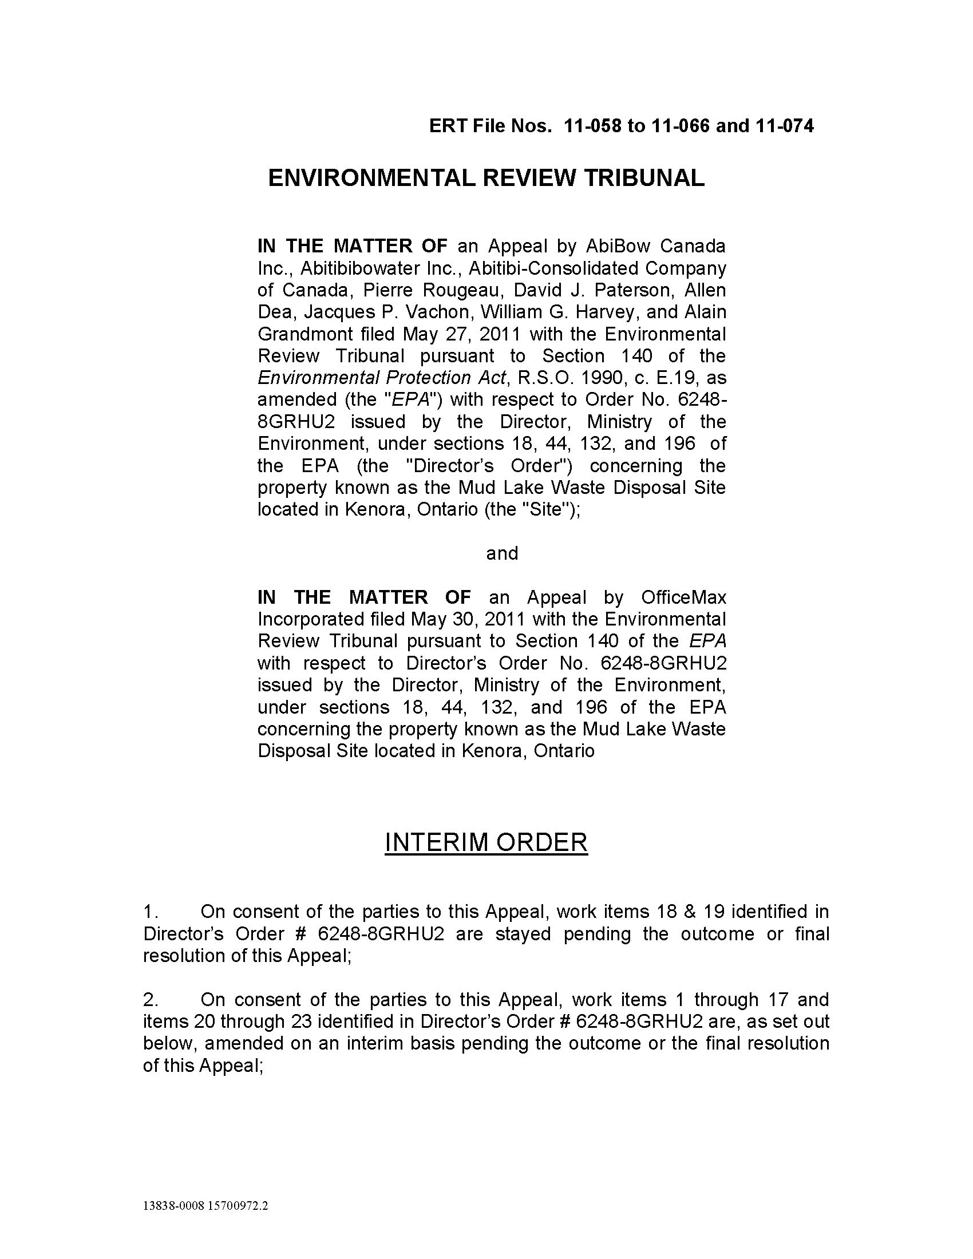
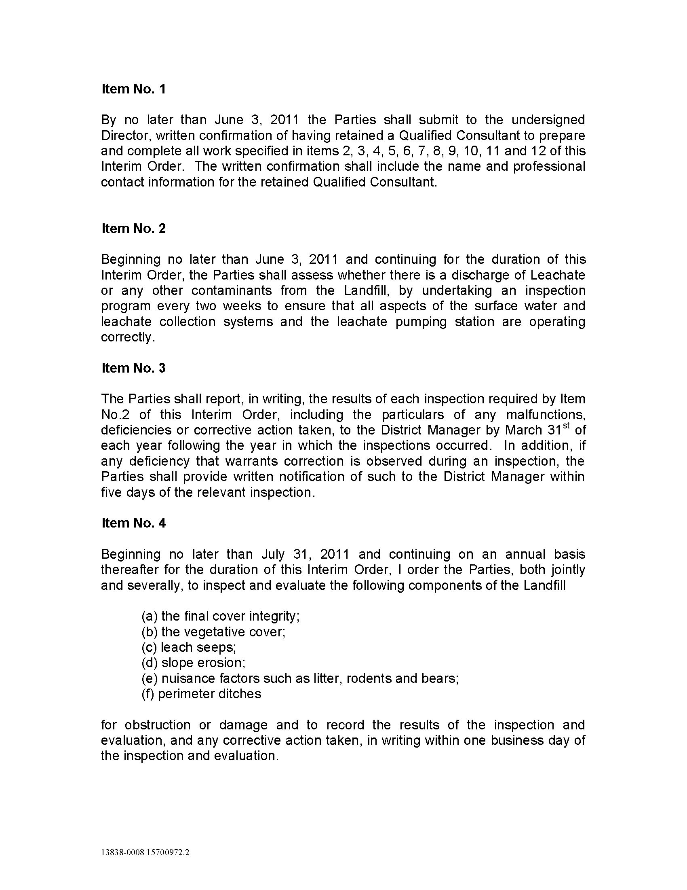
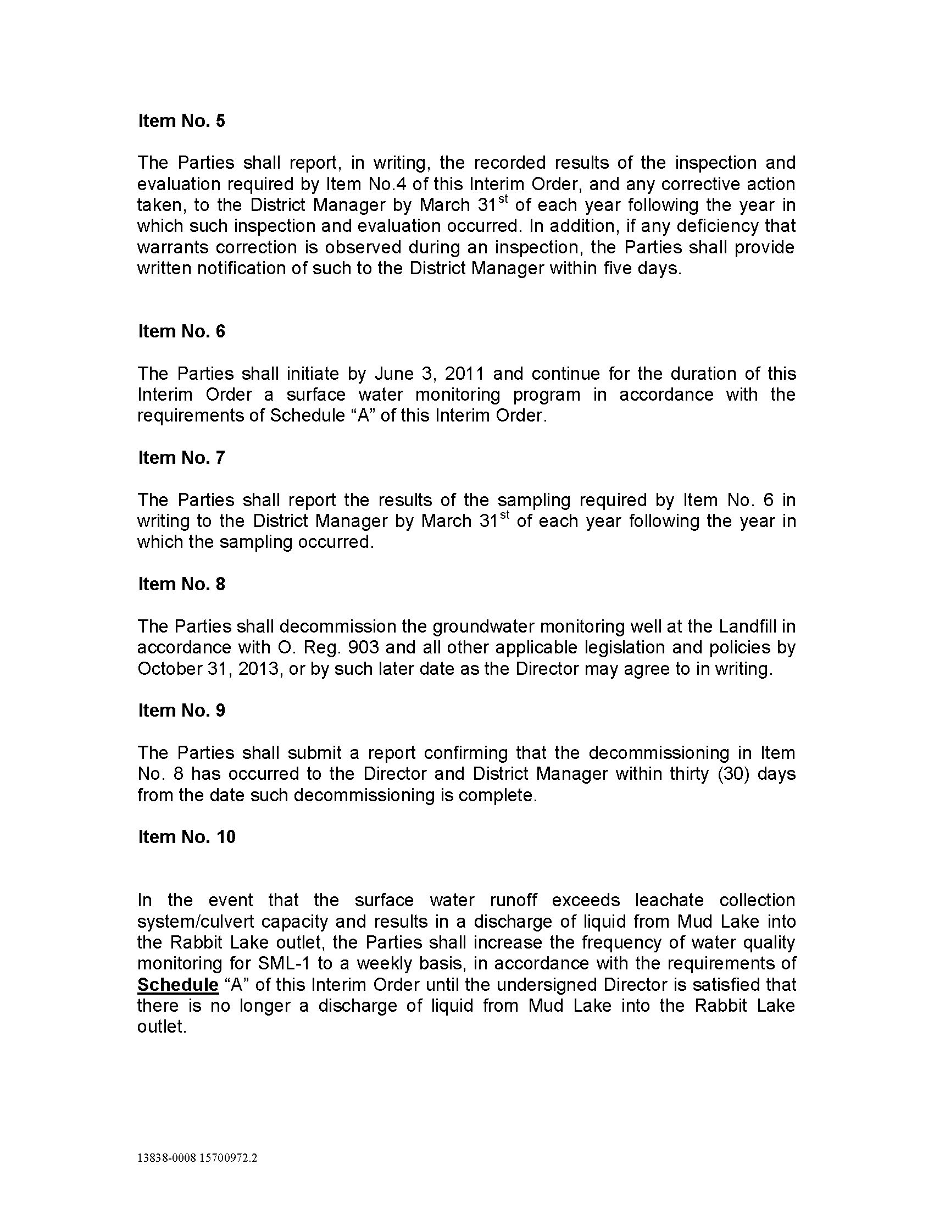
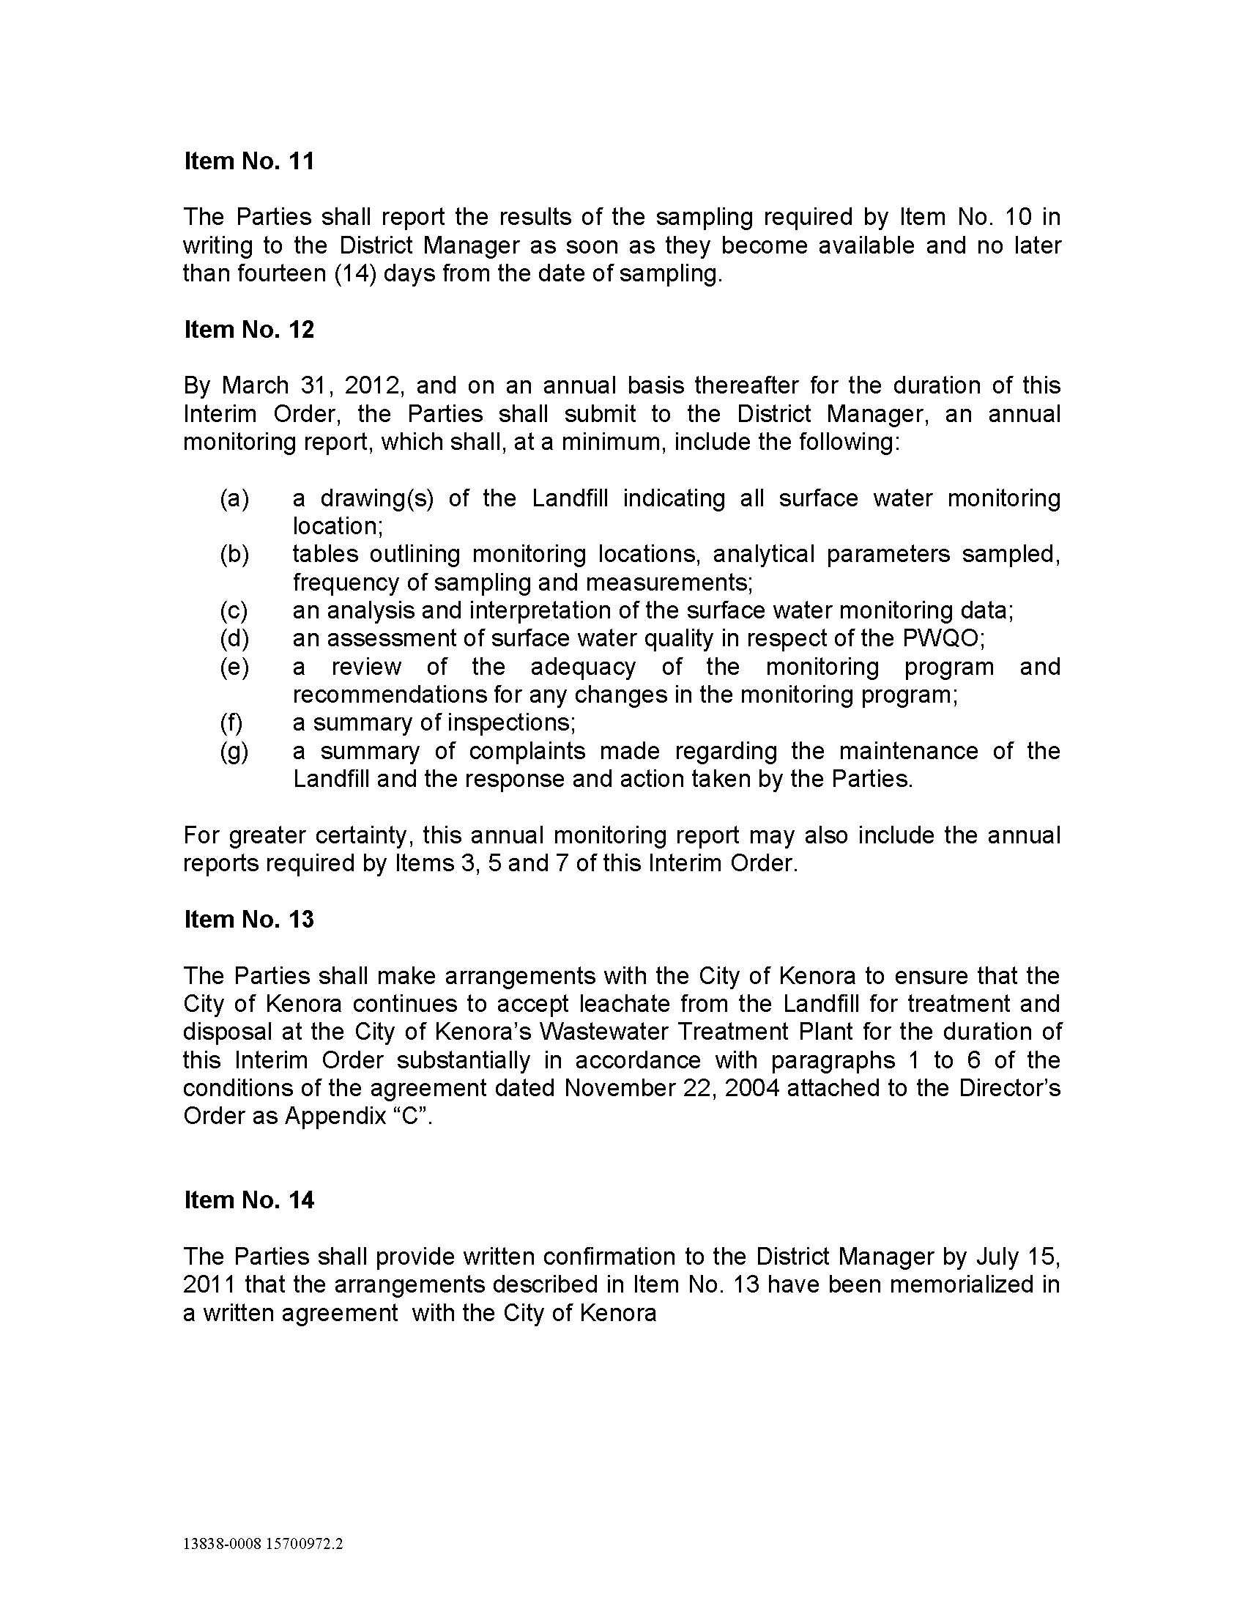
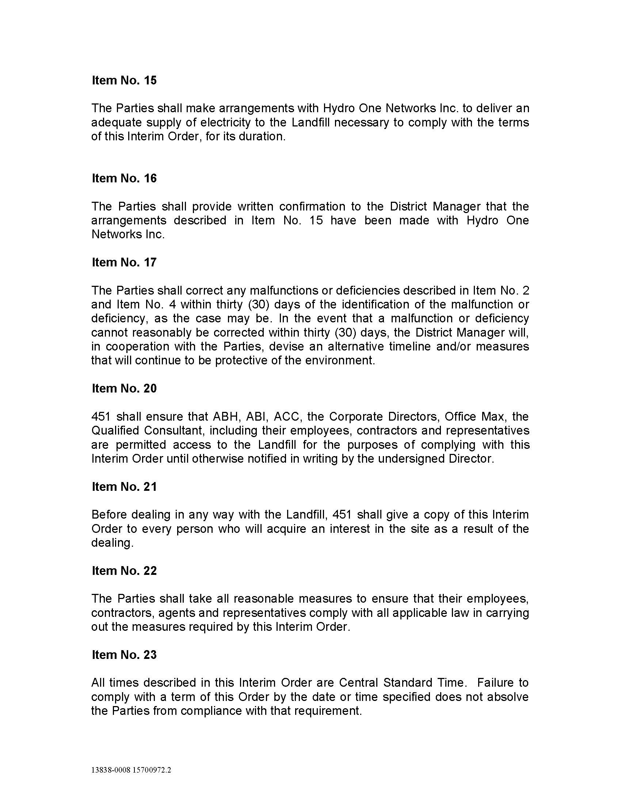
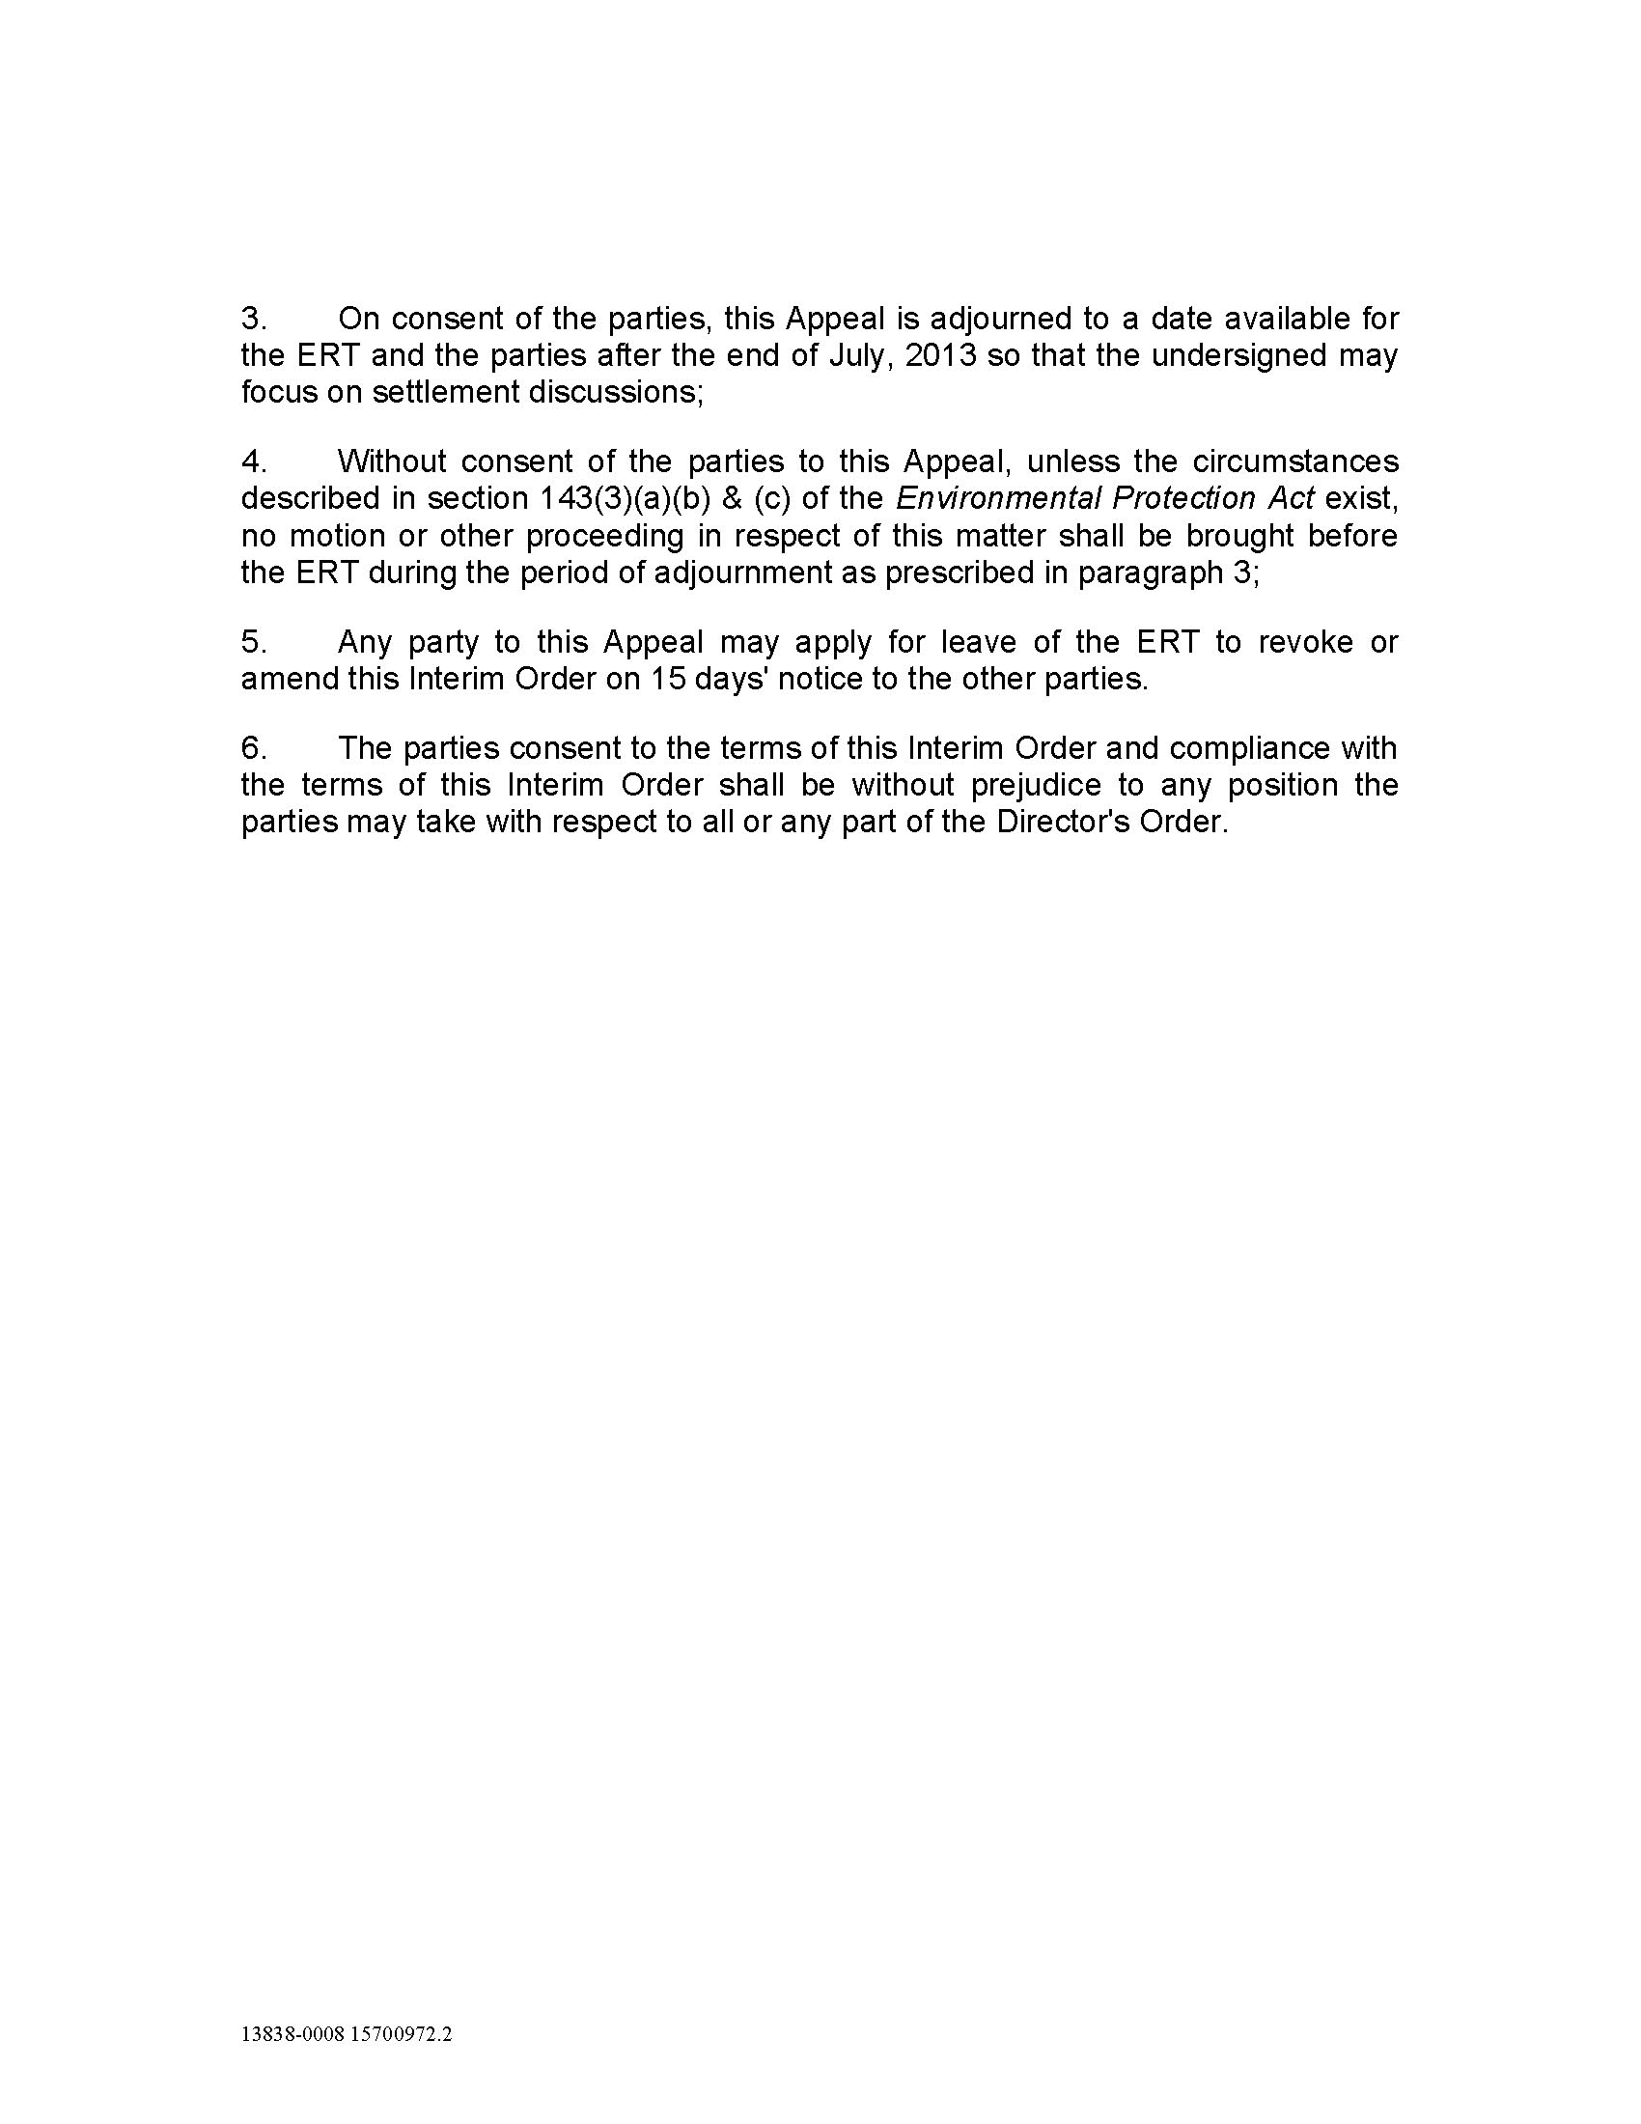
Mud Lake Interim Order – Schedule “A”

Surface Water Monitoring Program

Year: | 2013 | 2014 | 2015
Sampling Locations:¹ | SML-1 | SML-1 | SML-1
Sampling Frequency:² | Once per month  (Apr. to Oct. only) | Once per month  (Apr. to Oct. only) | Once every 3 months  (Beginning in March)
Parameter Sets: | A, B, C | A, B, C | A, D
Report Due March 31st of each year: | 2012 data | 2013 data | 2014 data

¹Monitoring Station: SML-1 - Culvert discharge offsite to Rabbit Lake outlet
² The sampling frequency is subject to the requirement of Item No. 10 of the Interim Order.

Parameter List
Set A  (Field Testing) | Set B  (Independent Lab Testing) | Set C  (Independent Lab Testing) | Set D  (Independent Lab Testing)
pH  Conductivity  Temperature  Dissolved Oxygen  Flow | Ammonia  pH  Conductivity  Total Dissolved Solids  Alkalinity  Hardness  Chloride  Sodium  Sulphate  Total Kjeldahl Nitrogen  Total Phosphorus  Phenols  BOD₅ | Arsenic  Cadmium  Calcium  Chromium III  Chromium VI  Cobalt  Copper  Lead  Magnesium  Nickel  Potassium  Ammonia  Nitrate plus Nitrite  COD  Total Organic Carbon  Tannin & Lignin  Aluminum  Barium  Total Iron  Manganese  Zinc | Arsenic  Ammonia / Unionized Ammonia  Cadmium  pH  Alkalinity  Total Phosphorus  Phenols  Chromium III  Chromium VI  Cobalt  Copper  Lead  Nickel  Aluminum  Total Iron  Zinc
Appendix B
Interim Order amending Director’s Order No. 8301-8HFPUQ
(August 16, 2011) – Margach Waste Disposal Site
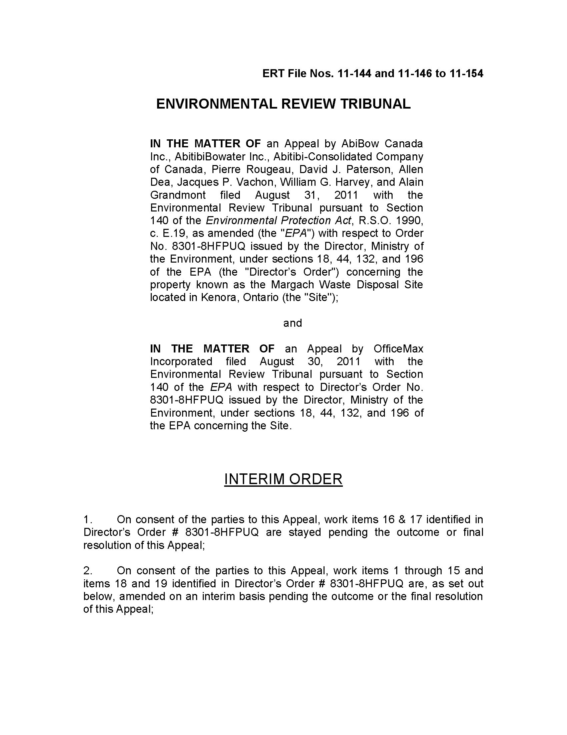
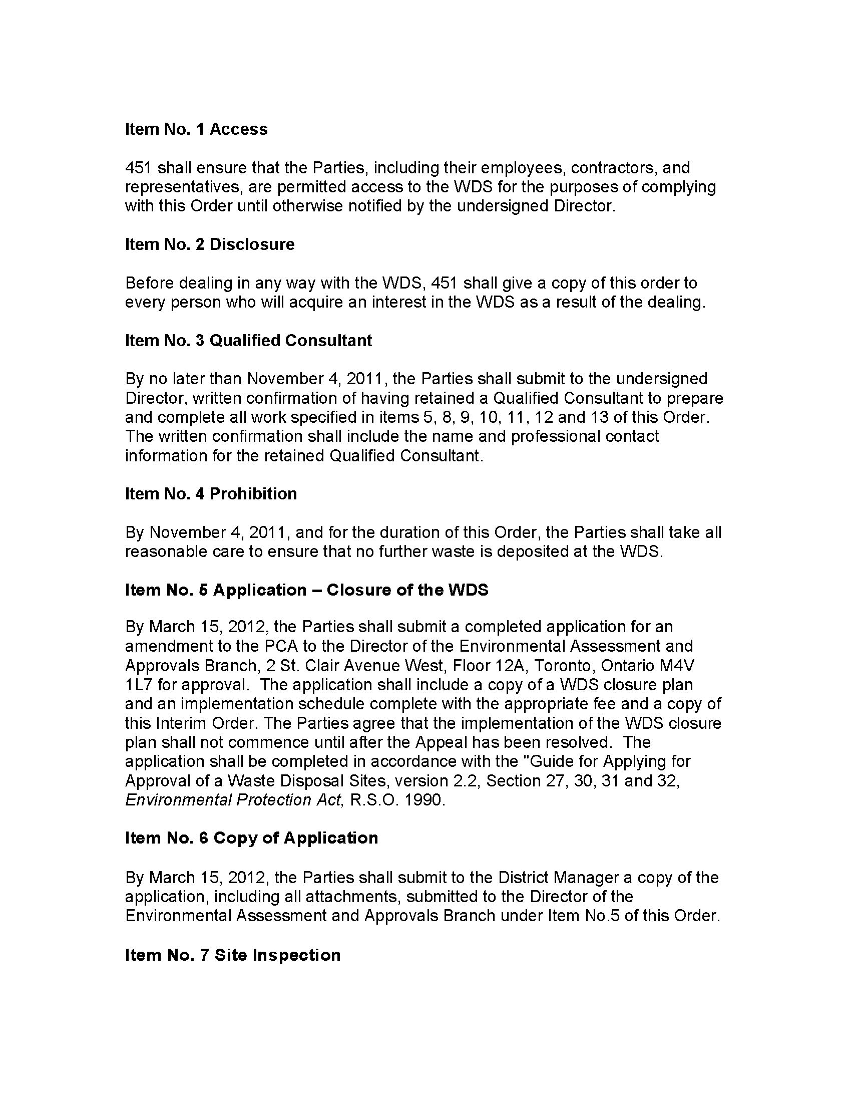
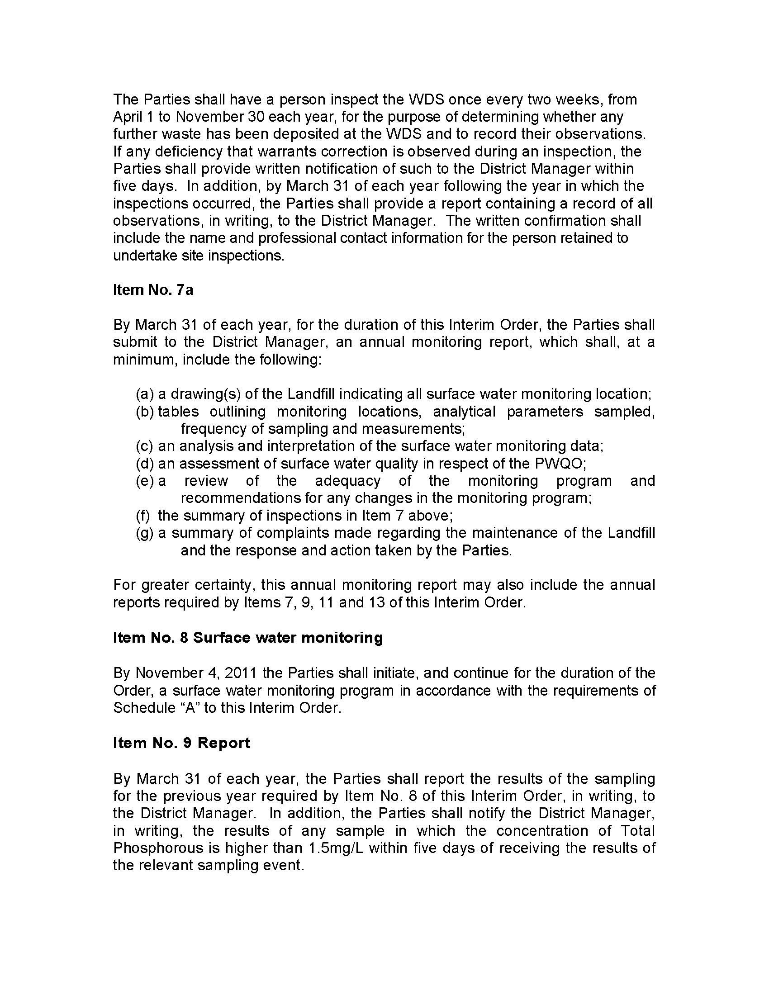
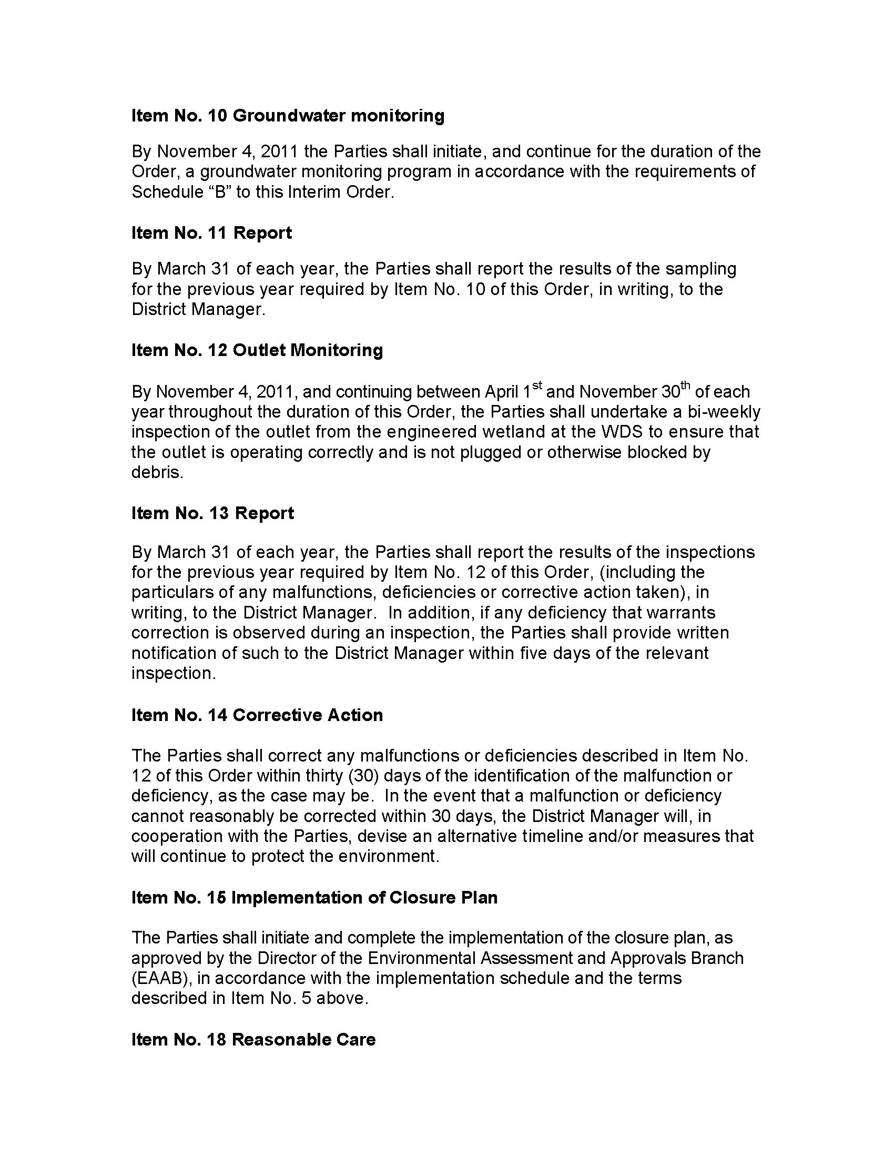
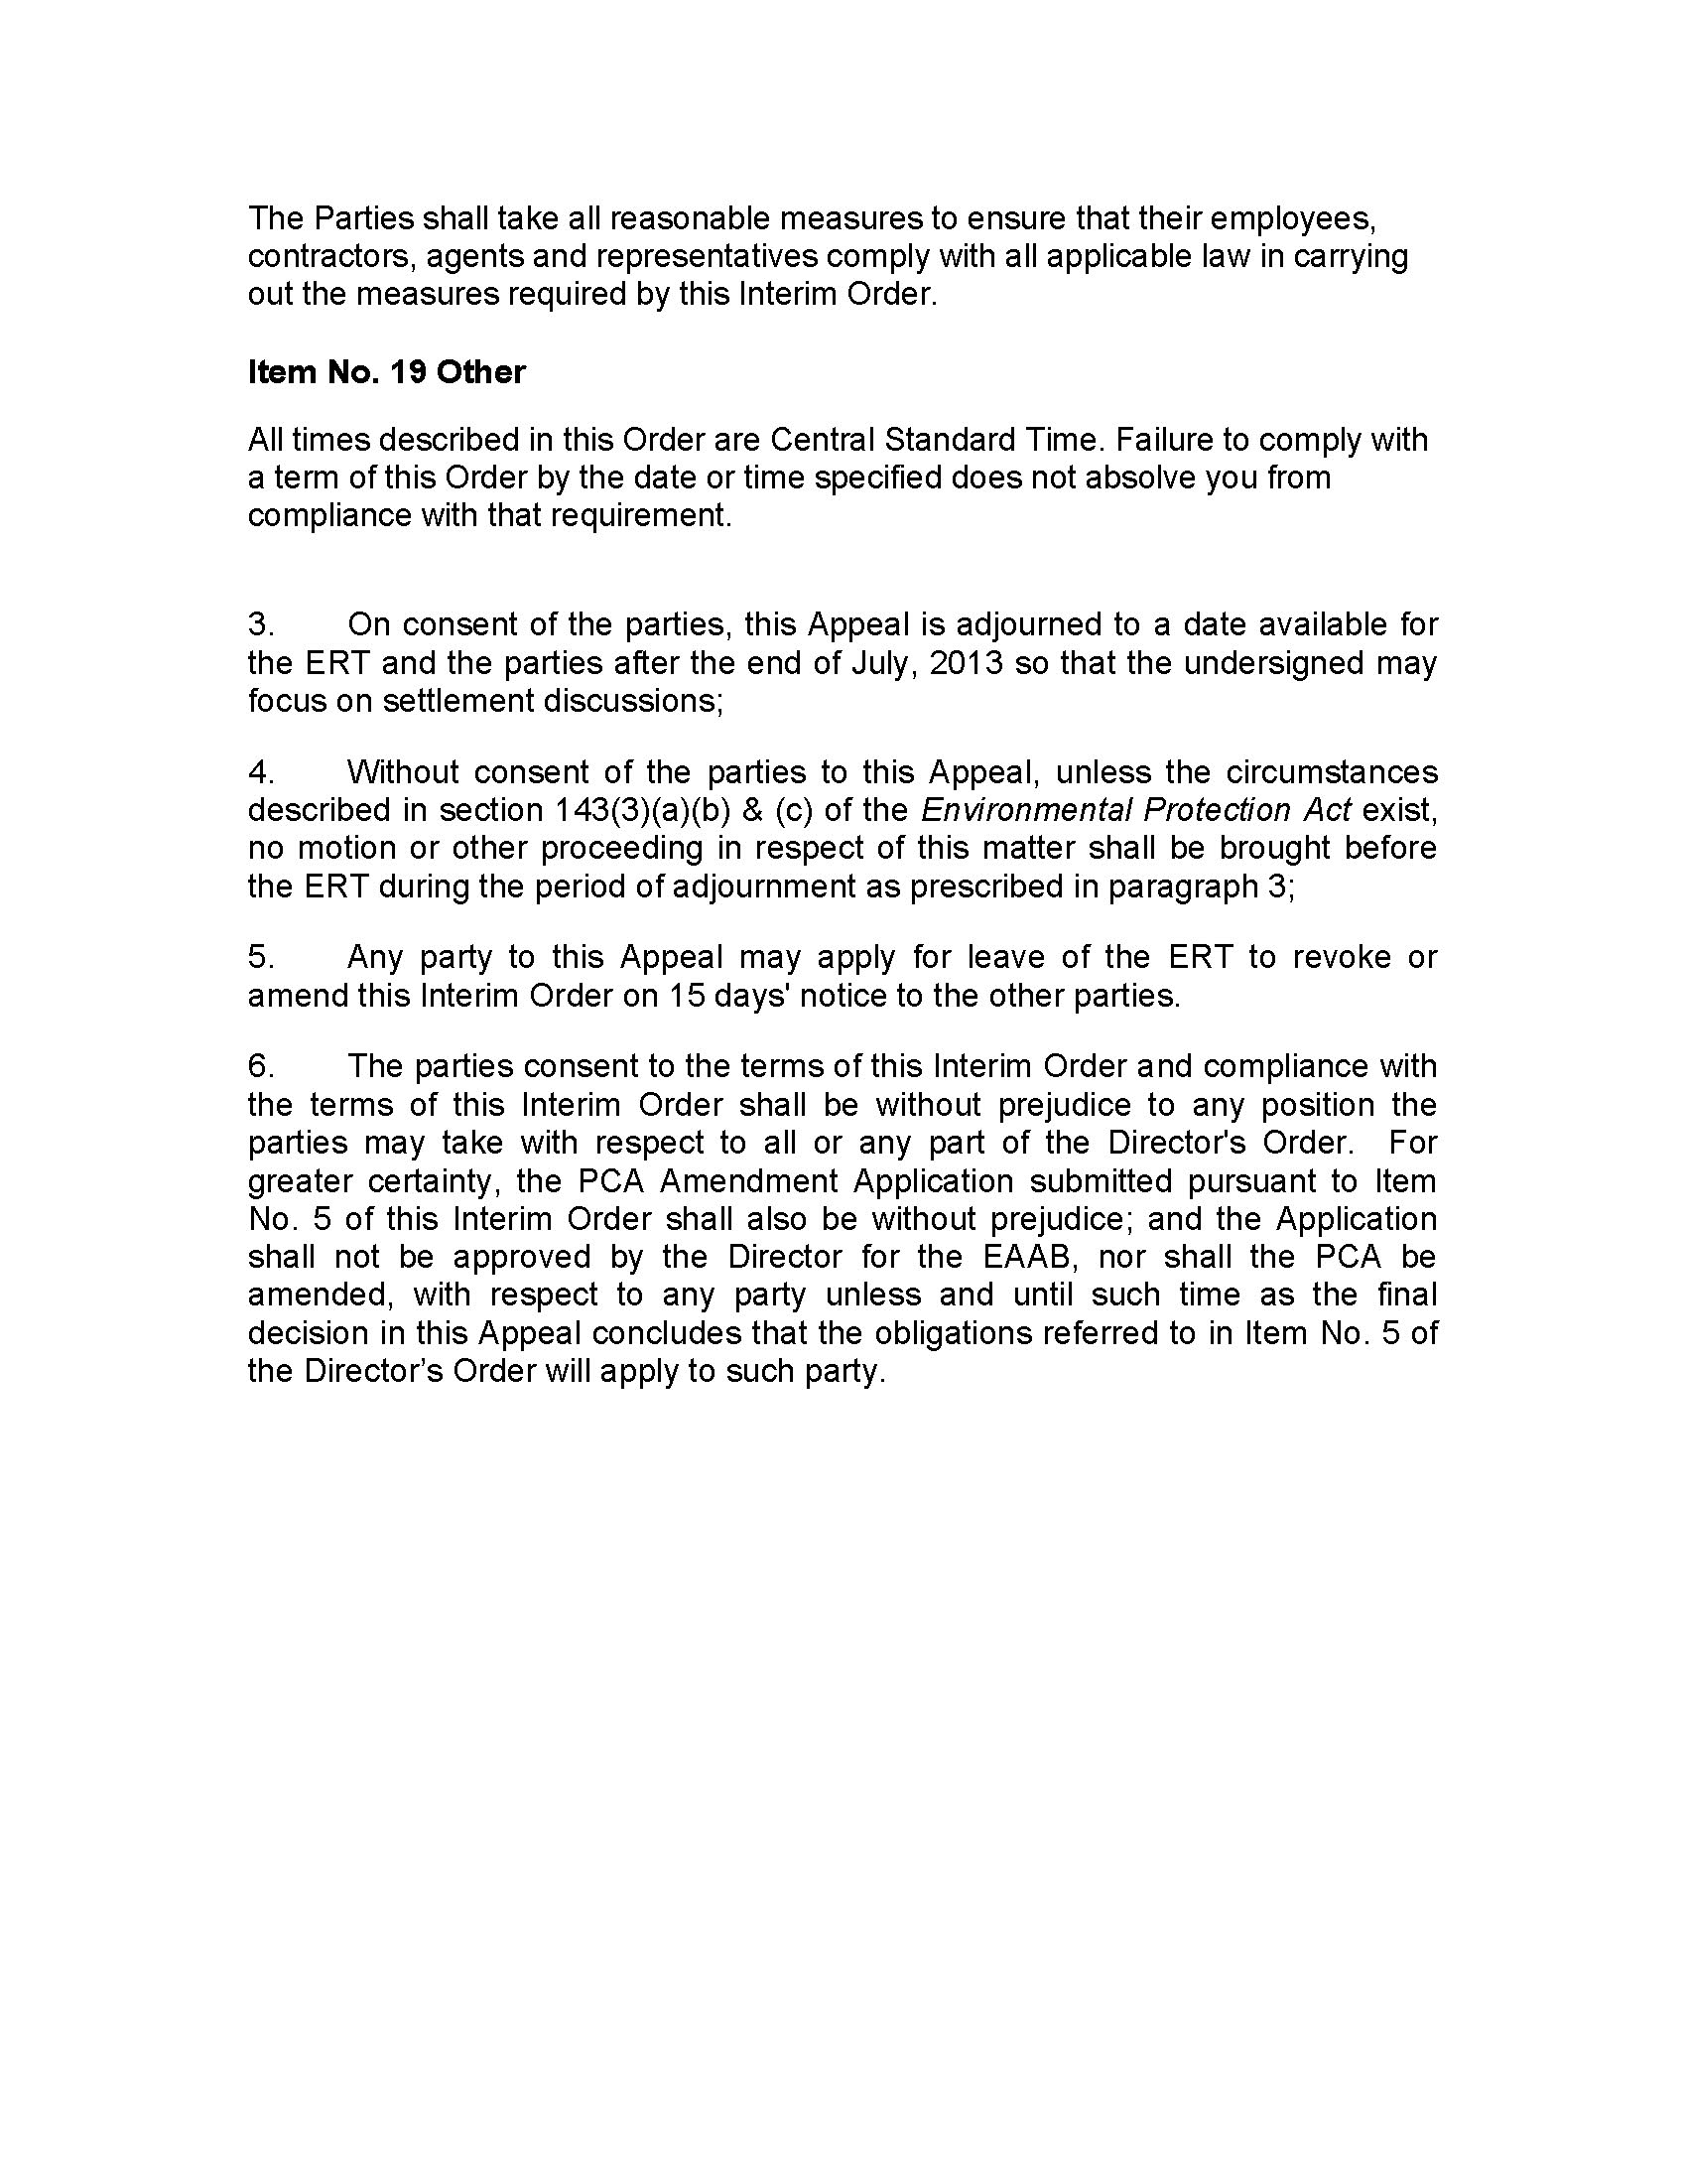
Margach Interim Order – Schedule “A”

Surface Water Monitoring Program

Year: | 2013 | 2014 | 2015
Sampling Locations: | SW1  SW2  SW6  SW8 | SW1  SW2  SW6  SW8 | SW1  SW2  SW6  SW8
Sampling Frequency: | Once per month  (Apr. to Oct. only) | Once per month  (Apr. to Oct. only) | Once per month  (Apr. to Oct. only)
Parameter Sets: | Total Phosphorus | Total Phosphorus | Total Phosphorus
Sampling Frequency: | Twice per year  (Spring freshet and Fall) | Twice per year  (Spring freshet and Fall) | Twice per year  (Spring freshet and Fall)
Parameter: | A, B, C | A, B, C | A, B, C
Report Due March 31st of each year: | 2012 data | 2013 data | 2014 data

Surface Water - Parameter List
Set A  (Field Testing) | Set B  (Independent Lab Testing) | Set C  (Extended List)
pH  Conductivity  Temperature  Flow (SW2, SW6 only) | pH  Conductivity  Total Dissolved Solids  Alkalinity  Hardness  Chloride  Sodium  Sulphate  Total Kjeldahl Nitrogen  Total Phosphorus  Phenols  BOD₅  Total Suspended Solids | Calcium  Magnesium  Potassium  Ammonia  Nitrate plus Nitrite  COD  Total Organic Carbon  Tannin & Lignin  Aluminum  Barium  Total Iron  Manganese  Zinc

Margach Interim Order – Schedule “B”

Ground Water Monitoring Program

Year: | 2013 | 2014 | 2015
Sampling Locations: | OW-13  DH-2, OW-1  OW-12, OW-20B  OW-7 or OW-7B  OW-9, OW-10  OW-16, OW-18 | OW-13  DH-2, OW-1  OW-12, OW-20B  OW-7 or OW-7B⁵  OW-9, OW-10  OW-16, OW-18 | OW-13  DH-2, OW-1  OW-12, OW-20B  OW-7 or OW-7B⁵  OW-9, OW-10  OW-16, OW-18
Sampling Frequency:² | Twice per year  (Spring freshet and Fall) | Twice per year  (Spring freshet and Fall) | Twice per year  (Spring freshet and Fall)
Parameter Sets: | A, B, C, D | A, B, C, D | A, B, C, D
Report Due March 31st of each year: | 2012 data | 2013 data | 2014 data

Ground Water - Parameter List
Set A  (Field Testing) | Set B  (Field Testing) | Set C  (Independent Lab Testing) | Set D  (Independent Lab Testing)
Groundwater Elevation | pH  Conductivity | pH  Conductivity  Total Dissolved Solids  Alkalinity  Hardness  Chloride  Sodium  Sulphate  Total Kjeldahl Nitrogen  Total Phosporus  Phenols | Calcium  Magnesium  Potassium  Ammonia  Nitrate plus Nitrite  COD  Total Organic Carbon  Tannin & Lignin  Aluminum  Barium  Total Iron  Manganese  Zinc

Monitoring stations: SW-1 (Background), SW2 (Start of wetland), SW6 (Exit of wetland; prop limit), SW8 (down gradient)
Applies only to total phosphorus
Monitoring stations: OW-13 (Background) DH2, OW-1 (west side) OW-12, OW-20B (South Side) OW-7 or OW-7B (Source) OW-9, OW-10 (South prop limit) OW-16, OW-18 (Attenuation Zone)
Only one of OW-7 or OW-7B must be monitored

